**Univariate Time Series Analysis For Weather Prediction Using Prophet Library**

Department of Computer Science Engineering

Geethanjali College of Engineering and Technology



Team Members

* T Lakshmi prasanna (19R11A05E0)
* T Manvitha (19R11A05D9)
* N Keerthana (19R11A05N6)
* V Likhitha (19R11A05E4)
* V Nithin (20R15A0516)

ABSTRACT

* Any data associated with the time that is dependent on time-related matters can be termed as time-series data.
* Time series analysis comprises methods for analyzing time series data in order to extract meaningful statistics like trends, nonstationarity, and seasonality based on a daily, weekly, yearly basis and other characteristics of the data.
* Time series forecasting is the use of a model to predict future values based on previously observed values.

**INTRODUCTION**

* There are many models present for the predictive analysis of time series like Machine learning ARIMA (Auto-Regressive Integrated Moving Average model), Auto-Regressive model, Exponential Smoothing, LSTM (Long Short Term Memory), etc. These models require the data to be fed and with certain tweaking and fine-tuning they help us to make predictions. .
* But, Facebook Prophet library is a third party library that could perform all the fine-tuning part within and we just need to feed the model.

Block diagram

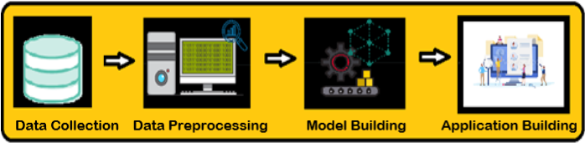

**PROBLEM FORMULATION**

The attribute of the application here serve as an input and the output is the predicted temparature.

**DATE :** On which date you want to forecast the weather.

Software Requirements

### In order to develop this project we need to install the following software/packages:

### Anaconda Navigator

### Jupyter notebook

### Spyder

### To build Machine learning models you must require the following packages:

### Numpy

### Fbprophet

### To make a responsive python script you must require the following packages:

### Requests

### Flask

### Need to download the required packages:

### pip install requests

### pip install Flask

### pip install pystan

### conda install -c  conda-forge fbprophet

**Model building**

**1.Data Cleaning and Filtering*:*** The raw data considered for the problem statement needs some pre-processing and cleaning depending on its attributes' value. Firstly, all the records with NULL value in either of the attributes were pruned as they can't be handled with any random values.

**2.Date Time object :**When a csv file is imported and a Data Frame is made, the Date time objects in the file are read as a string object rather than Date Time object and Hence it’s very tough to perform operations like Time difference on a string rather a Date Time object.

#Pandas to_datetime() method helps to convert string Date time into Python Date time object.

**3. Resampling :**Resampling is necessary when you’re given a data set recorded in some time interval and you want to change the time interval to something else. For example, you could aggregate monthly data into yearly data, or you could upsample hourly data into minute-by-minute data.

**4. Interested about two columns :**For time series analysis,weare interested about two columns i.e., date(datetime_utc) and temperature(_tempm). So let us concentrate only on them.

**5. Model Fitting :**The API implementation for Prophet and Scikit-learn are very similar as we’ll see below. We start by creating an instance of the Prophet class and then fit it to our dataset.

# **6. Making Future Predictions :**The next step is to prepare our model to make future predictions. This is achieved using the Prophet.make_future_dataframe method and passing the number of days we’d like to predict in the future. We use the periods attribute to specify this. This also include the historical dates.

**7. make_future_dataframe() :**Now, a dataframe having 365 days is created using make_future_dataframe() function of prophet and the model makes forecast in this dataframe.

**8. Let us visualise the data :**

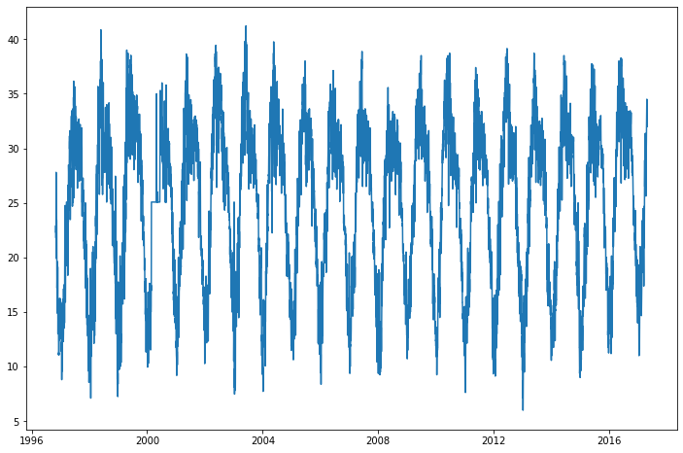

**9.Obtaining the Forecasts :**We use the predict method to make future predictions. This will generate a dataframe with a yhat column that will contain the predictions.

# **10. Plotting the Forecasts :**

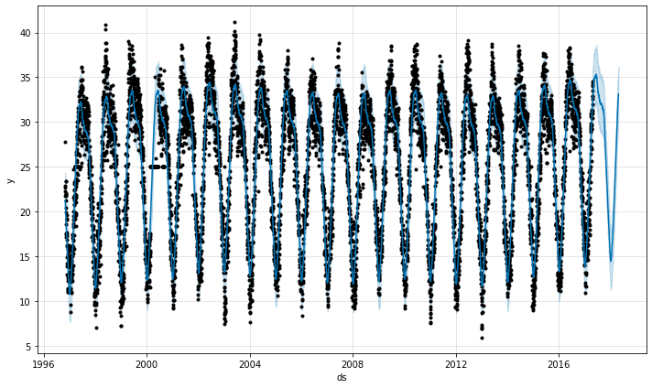

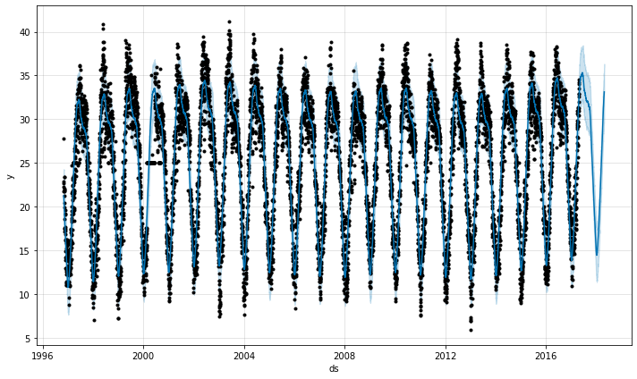

**The actual value and predicted value seems to be pretty similar.**

**Hence the model is working well**

# **11. Cross Validation:**The cross_validation method allows us to compare the predicted values with the actual values in Prophet.

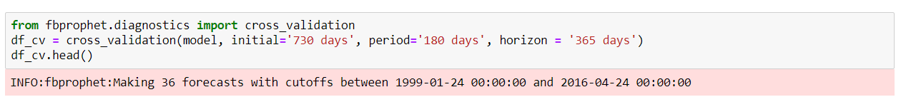

# **12.Visualizing Performance Metrics**: The performance Metrics can be visualized using the plot_cross_validation_metric utility. Let’s visualize the RMSE below.

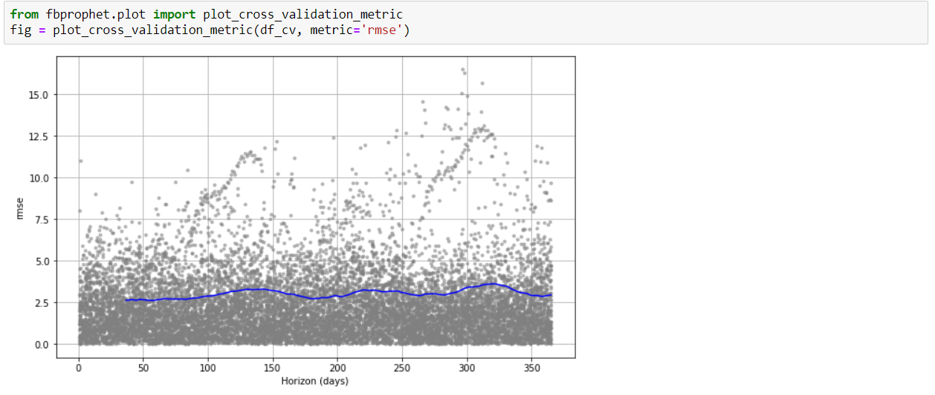

# **13. saving the model file :**

**14.Frontend UI Design :**Here we use html ndcss code to develop frontend UI and the code will be available in APPENDIX part of doc.

**15. Flask :**Here we use the flask to integrate python script and html code . and here we load our model in the code.

**FLOW CHART**

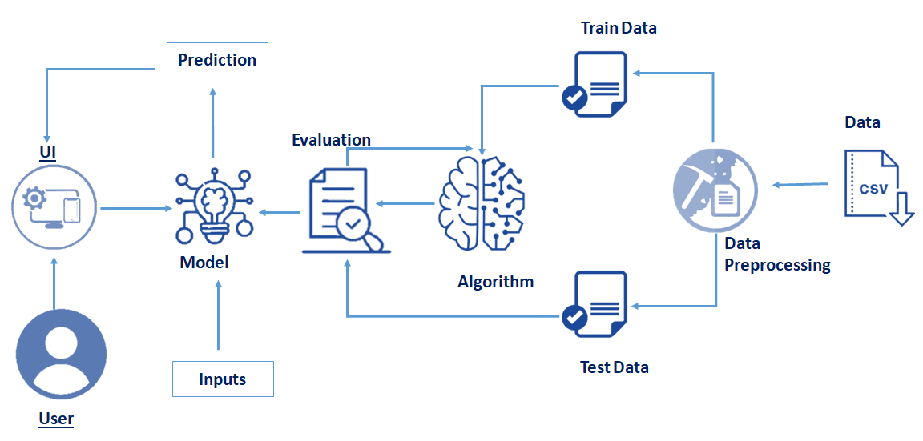

**RESULT**

### Run The App :

**Run The app in local browser**

* Open anaconda prompt from the start menu
* Log on to the created virtual environment by using the command - “conda activate environment_name”
* Navigate to the folder where your python script is.
* Now type “python app.py” command
* Navigate to the localhost where you can view your web page

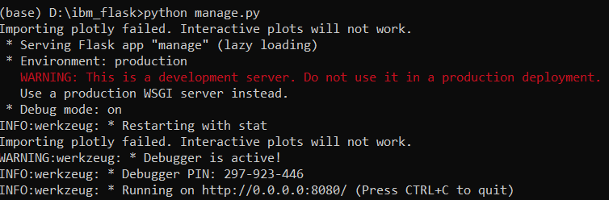

### 

### Now open your browser and navigate lo localhost:8080 where we can view our webpage

### The output of the project :

### 

### Here I give some input date and clicked the submit then it showed the predicted temperature

### 

**Applications**

**.** The Time Series Analysis is applied for various purposes, such as:

* Stock Market Analysis

* Economic Forecasting

* Inventory studies

* Budgetary Analysis

* Census Analysis

* Yield Projection

* Sales Forecasting

**Conclusion**

Univariate Time Series Analysis is a complex and challenging science that depends on the efficient interplay of weather observation, data analysis by meteorologists and computers, and rapid communication systems. But it has enormous uses which makes it an essential operation.

**Future scope**

Time series analysis helps in analyzing the past, which comes in handy to forecast the future. The method is extensively employed in a financial and business forecast based on the historical pattern of data points collected over time and comparing it with the current trends.This is the biggest advantage used by organizations for decision making and policy planning by several organizations.

**Bibliography**

Abraham, B. (1982). Temporal aggregation and time series, International Statistical Review,50, 285-291.

Abraham, B., and Box, G. E. P. (1979). Bayesian analysis of some outlier problems in time series,Biometrika, 66, 229-236.

Abraham, B., and Chuang, A. (1989). Outlier detection and time series modeling, Techitometrics,31, 241-248,

Abraham, B., and Ledolter, J. (1983). Statistical Methods for Forecasting, John Wiley, New York.

Abraham, B., and Ledolter, J. (1984). A note on inverse autocorrelations, Biometrika, 71, 609-614.

Abraham, B., and Wei, W. W, S. (1984). Inferences about the parameters of a time series model with changing variance, Metrika, 31, 183-194.

Agiaklogion, C., and Newbold, P. (1992), Empirical evidence on Dickey—Fuller-type tests, Journal of Time Series Analysis, 13, 471-483.

Absanullah, M., and Wei, W. W. 8. (1984a). Effects of temporal aggregation on forecasting in an

ARMA(I, 1) process. ASA Proceedings of Business and Economic Statistics Section, 297-302.

Ahsanullah, M., and Wei, W. W. S. (1984b). The effects of time aggregation on the AR(1) process,Computational Statistics Quarterly, 1, No. 4, 343-352.

**THANK YOU**

**CSE – 2**

**TEAM - 05**